Chapter 6 Sustainability
extra worksheet 2: The phosphorus cycle

The phosphorus cycle
Phosphorus is an essential element of DNA, cell membranes, bones and molecules important to the processes that release and use energy in the body.
Phosphorus is like carbon and nitrogen in that it cycles through natural ecosystems. However, unlike these other elements, phosphorus is not present in the air. Phosphorus is found in sedimentary rocks. The phosphorous cycle begins with phosphate ions (PO₄) in sedimentary rocks such as limestone.
Water percolating through the soil dissolves phosphate ions from the rock and distributes them through the soil. Some of the phosphate ions remain in the soil; others move into the ground water and into rivers and streams.
Phosphate ions in the soil are absorbed by plant roots and used and stored within the plant. Animals then eat the plants and so the phosphorous passes up the food chain. When dead plants and animals and their wastes are decomposed, phosphorus is returned to the soil.
Once it gets into the soil the phosphorus is available to be taken up by plants once again and so the cycle continues. However, some of the phosphorus may move through the soil dissolved in rain water. It may be carried into rivers and into oceans hundreds or thousands of kilometres away from where the phosphorus was released. The phosphorus may circulate in the ocean, entering the ocean food webs through algae. Alternatively, the phosphorus may settle in the sediments at the bottom of a lake or the ocean. There it becomes part of sedimentary rocks, such as limestone, and is lost to the cycling process for hundreds of thousands or millions of years. The phosphorous cycle is shown in Figure 1.
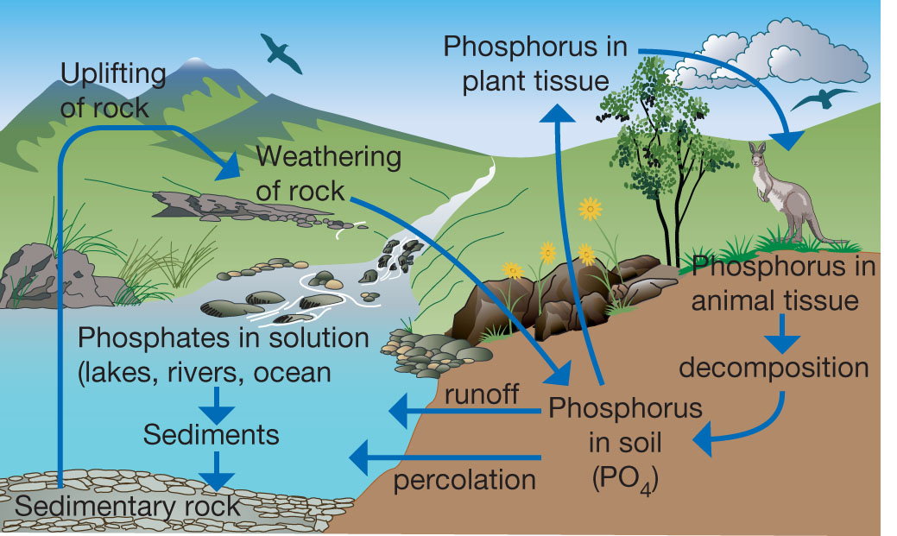
Figure 1 The phosphorus cycle.
In natural ecosystems, phosphorus is added to the soil when rocks are weathered and when plant and animal wastes are decomposed. In urban environments, phosphorus from sewage treatment plants goes out to the ocean. In agricultural (farm) ecosystems, the plants and animals are taken to market. The phosphorus is added to the urban ecosystem instead of being recycled. The soils in agricultural ecosystem are therefore running out of phosphorus. To maintain healthy crops, farmers have to add phosphorus to soils through using fertilisers.

Questions
1 Compare the phosphorus cycle with the carbon cycle.

2 Explain how phosphorus moves through a food chain.

3 Explain how phosphorus is returned to the soil from living things.

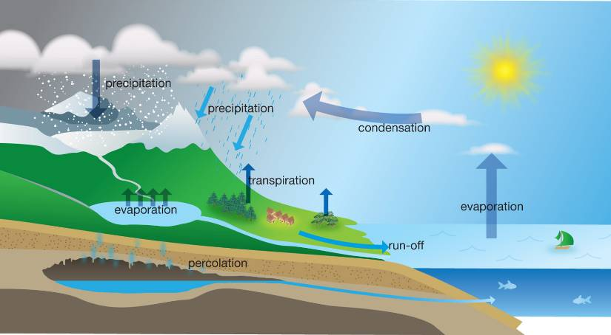
Figure 2
The water cycle.
4 a Deduce how the water cycle shown in Figure 2 plays an important part in the movement of phosphorus in the phosphorus cycle.

b Identify the processes in the water cycle that have a significant effect on the phosphorus cycle.

5 The phosphorus cycle could be described as a figure-of-eight with the two circles crossing at phosphorus in the soil. Distinguish the components of these two circles and draw the two circles side by side.

